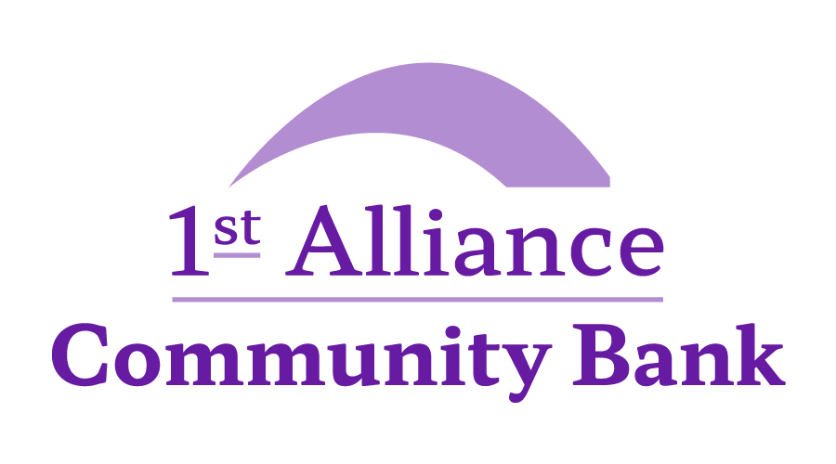

MEMBERSHIP APPLICATION

1st Alliance (Ayrshire) Credit Union
147 Main Street, Kilwinning, Ayrshire, KA13 6EQ
Tel: 01294 557123
Email: info@allianceayrshire.co.uk

Please complete all sections and return with: Photo identification; Posted proof of address
(no more than three months old) and your first deposit.

Personal details:
Title: MR/MS/MISS/MRS

First name: Last name:

Gender M/F No of Children at home: Date of Birth: __/__/____

Nationality: Country of birth:

Yearly Statements Y/N Marital Status:

Contact information:

Home phone: Mobile:

Email address:

Address If less than 3 years please provide your previous address

Current Address Previous Address

House number/name: House number/name:

Street: Street:

Town: Town:

County: County:

Post Code: Post Code:
Shared Letterbox: Y/N Shared Letterbox: Y/N
Time at address YY/MM: Time at address YY/MM:
Nomination: I hereby nominate the below named person (s) to receive any life benefit on my account and to become entitled to such property in the credit union, not exceeding the limit of the amount for the time being authorised by law I may have at the time of my death. NOTE: Under section 21(4) of the Credit Union Act 1997, a nomination shall not be revocable or variable by the will of the nominator or by any codicil of his/her will. Under section 21(6) of the Credit Union Act 1997, the marriage of a member of a credit union shall operate as a revocation of any nomination made by him/her before his/her marriage.
Name: Relationship
Address:
Managing your account

As well as my Share account please open: Summer Y/N Christmas Y/N

How will you pay into your account? Head Office/ Standing Order / Telephone payments

Payroll Deduction

You can also pay via payroll: North Ayrshire Council / Ayrshire Housing / Seascape / Hansel

Payroll number: NI:

Pay frequency W/F/M Deduction amount: £

Employment details:

Working/Self-employed/Retired/Unemployed/Homemaker/Student Income level: £15.000 and below/£15-£30,000/£30k +

Bank details Please provide bank details for withdraws and loans:

Name of bank: Name on account:

Sort code: _ _ _ _ _ _ Account number: _ _ _ _ _ _ _ _

Contact preferences
opt into your preferred contact methods:
Circle your preferred method (s)Home phone Y/N Mobile Phone Y/N Mail Y/N E-Mail Y/N

Do you have or have had a Sequestration/Trust Deed or Debt Arrangement Scheme? Y/N

For your information
Membership terms and conditions

A share account will be opened on receipt of completed application and all documentation
A balance of £1 is required to retain membership
Members are expected to save regularly into their share account.
An annual service fee of £10 will be taken from the shares account on 1st September . Accounts with less than the £10 will be closed.
An annual dividend may be paid, gross of tax, on the share account, subject to surplus. Dividend rates will be decided at the AGM.
Default in loan will result in transfer of any savings held.
Shares are used as security for loans and as such cannot be withdrawn when lower than loan balance.

Data Protection Statement
In accordance with the principles of the Data Protection Act 1998, we will use your personal details for the purpose of managing your accounts with the Credit Union. Your Personal Details will be treated confidentially and will only be shared with other agencies for the purpose of credit referencing and debt recovery, for which purpose we hold a category F Consumer Credit License.
Credit References and Fraud Agencies
We may make searches about you at credit reference agencies who will supply us with credit information as well as information from the electoral register. The agencies will record details of any search whether or not this application proceeds. We may use credit scoring methods to assist this application and to verify your identity. Credit searches and other information which is provided to us and/or the credit reference agencies about you, and anyone with whom you are linked financially, may be used by us if credit decisions are made about you or anyone with whom you are linked financially or other members of your household.

Your consent: It is important that you read and understand the section entitled ‘For your information’. By signing this application, you agree that we can use your information in this
way. In accordance with data protection requirements you have the right of access to your information held by Credit Union on payment of a fee.
Credit Union Membership with other Credit Unions
I hereby apply for membership of 1st Alliance (Ayrshire) Credit Union. I agree to abide by the rules and declare that I am not and have not been a member of any other credit union other than:
Credit Union Limited
I also declare that the information I have given on this form is true to the best of my knowledge. I have read the terms and conditions of the account and I accept them. I authorise you:
To open the account in my name
To provide me with lending facilities as appropriate
To process the information, I have provided you with
To honour my signature as shown below for all purposes.

SIGNED DATE

